Module 02 Web Development, Design and Version Control

You will submit this with your guided exploration.

Use headings to organize topics and create a table of contents to be able to quickly access information. Here is how to add headings and subheadings:

* [Headings, Subheadings, and Table of Contents (Google Docs)](https://guides.lib.uni.edu/c.php?g=1243498&p=9758563)
* [Headings, Subheadings, and Table of Contents (Microsoft Word)](https://guides.lib.uni.edu/c.php?g=1243498&p=9207893)

As you add new headings to organize your documentation, refresh the table of contents below.

|  |
| --- |
| General Resources  Web Development  HTML  Overview of HTML  HTML Attributes and Comments  CSS Basics  Bootstrap  Version Control  Web Accessibility and Inclusive Design  [Lists](https://www.w3schools.com/html/html_lists.asp) |

Make your own technical documentation to help you learn and have resources to help you on your projects.

|  |
| --- |
| **DOs and DON’Ts** |
| DO: Provide clear and simple explanations in your own words (be concise)   * Use short sentences, small paragraphs * Use lists and tables to organize information * Use standard industry terms but explain in simple language   **DON’T copy my explanations from the slides as yours.** |
| DO Use Code Snippets and Visuals to reduce lengthy explanations:   * Include code examples you created * Include comments to describe parts of your code * Include Screenshots, GIFs, Images   **DON’T use my slides as your image**  **DON’t copy my code examples** |
| DO Include Resources that give steps or help explain concepts   * You can include resources given in the lecture or find your own but   + Include website link with summary   + Include links to videos with summary of content |
| DO Use AI to help you learn   * Ask questions to understand concepts better, give examples for it to explain in simple terms, ask for AI to provide different examples * Ask AI for resources so you can cite and provide AI Tool Name and include the URLs to the main resources that helped you * Summarize in your own words and include * Use AI to create images that you describe   **DON’t**  use AI to create your technical documentation. |

# General Resources

Here you can list general resources that you use frequently for this module. Add other general resources to quickly get help on topics in this module.

* Class Resources[M02 Web Development and Inclusive Design](https://drive.google.com/drive/folders/1FSCmM7-ftSkk0hlosgoMjCjSV4w7GuVn)
* [HTML Tutorial](https://www.w3schools.com/html/default.asp)
* [HTML Styles CSS](https://www.w3schools.com/html/html_css.asp)
* [Get started with Bootstrap · Bootstrap v5.3](https://getbootstrap.com/docs/5.3/getting-started/introduction/)
* [Git Tutorial - GeeksforGeeks](https://www.geeksforgeeks.org/git/git-tutorial/)
* [Hello World - GitHub Docs](https://docs.github.com/en/get-started/start-your-journey/hello-world)

You will also add resources to more detailed examples in each section below.

# Web Development

## HTML

Here are examples of technical documentation to help you get started.

Notice how I didn’t copy and paste from lecture, created new examples and used highlighting, screenshots and images.

1. I create a heading 3 for the Overview of HTML and updated the table of contents
2. I highlighted examples to help understand vocabulary for start tag and end tag
3. Included a link and screenshot from a web page to understand HTML page structure. I updated the link with the title and not just a URL.
4. I created a table that was shaded to include a code example

### Overview of HTML

HTML provides structure for a web page using elements. Most elements have a start and end tag.

Here is an example of the heading 1 element

<h1>My Top Heading</h1>

<h1> is the start tag

</h1> is the closing tag

My Top Heading is the content to be displayed as a heading on the webpage

[Introduction to HTML](https://www.w3schools.com/html/html_intro.asp) -- explains the structure of a web page and HTML elements.

Here is the basic structure of a web page. The content visible on a web page goes in the body.

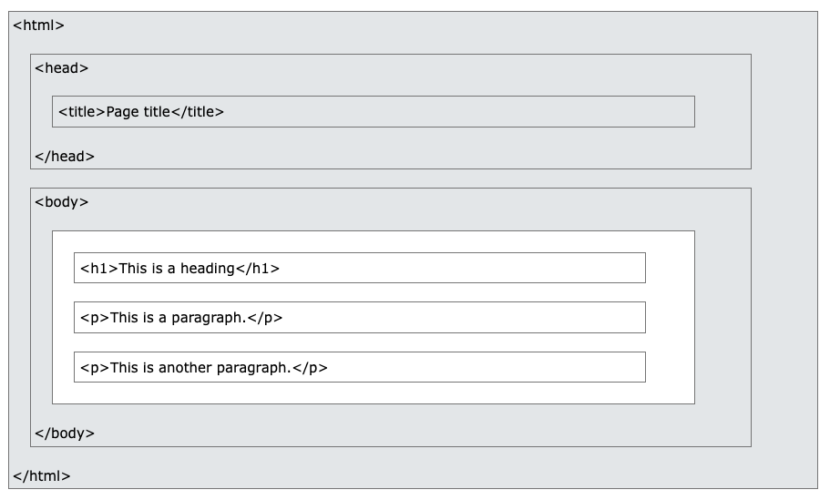

Example of an HTML web page created using [My First Heading](https://www.w3schools.com/html/tryit.asp?filename=tryhtml_elements)

|  |
| --- |
| <!DOCTYPE html>  <html>  <body>  <h1>HTML</h1>  <p>HTML elements are structured to build a web page</p>  <h2>Headings</h1>  <p>You can add different sized headings from h1 to h6</p>  </body>  </html> |

### HTML Attributes and Comments

Various attributes coded in a practice editor: img src, paragraph, heading

Attributes – Tags(start and end) – Values -

|  |
| --- |
| <!DOCTYPE html>  <html>  <head>  <title>Page Title</title>  </head>  <body>  <h1>Basics of HTML</h1>  <p>First things first: Open with the html tag</p>  <h2>This is just the beginning</h2>  <p>Everything great, begins with something small.</p>  <img src="https://www.ediningexpress.com/live20/business_data/templates/towncenterpizza/images/bg.jpg"  alt="Papa John's Pepperoni Pizza"  width="400" height="300">  </body>  </html> |

Hyperlink

|  |
| --- |
| <!DOCTYPE html>  <html>  <body>  <h2>The href Attribute</h2>  <p>HTML links are defined with the a tag. The link address is specified in the href attribute:</p>  <a href="https://github.com/">Direct Link to my github.</a>  </body>  </html> |

Link tag = <a></a>

The attribute = href=”url”

**Comment:** Comments do not appear on the browser

This is a comment: < ! - -Comment- - >

[HTML Tutorial](https://www.w3schools.com/html/default.asp)

[W3Schools Tryit Editor](https://www.w3schools.com/html/tryit.asp?filename=tryhtml_intro)

**Do Not Forget to commit and push!!**

### **LISTS**

Unordered lists(bullet-point) - <ul></ul>

Ordered Lists(Numerical) - <ol></ol>

|  |
| --- |
| <!DOCTYPE html>  <html>  <body>  <h2>An Unordered HTML List</h2>  <ul>  <li>Coffee</li>  <li>Tea</li>  <li>Milk</li>  </ul>  <h2>An Ordered HTML List</h2>  <ol>  <li>Coffee</li>  <li>Tea</li>  <li>Milk</li>  </ol>  </body>  </html> |

## CSS Basics

[HTML Styles CSS](https://www.w3schools.com/html/html_css.asp)

|  |
| --- |
| <!DOCTYPE html>  <html>  <body>  <h1 style="color:blue;">A Blue Heading</h1>  <p style="color:red;">A red paragraph.</p>  </body>  </html> |

## Bootstrap

[Bootstrap 5 Containers](https://www.w3schools.com/bootstrap5/bootstrap_containers.php)

Containers adjust the view and alignment of a webpage, they can be fluid and adjust to the screen size and position, or they can be the full width of the page.

|  |
| --- |
| <div class="container">  <h1>My First Bootstrap Page</h1>  <p>This part is inside a .container class.</p>  <p>The .container class provides a responsive fixed width container.</p>  <p>Resize the browser window to see that the container width will change at different breakpoints.</p>  </div> |
| <div class="container-fluid">  <!-- Full-width content -->  </div> |
| <div class="container">  <!-- Content here -->  </div> |

Creating grids for containers:

|  |
| --- |
| [Bootstrap 5 Grid Basic](https://www.w3schools.com/bootstrap5/bootstrap_grid_basic.php) |

Creating an image carousel with Bootstrap

[Bootstrap 5 Carousel](https://www.w3schools.com/bootstrap5/bootstrap_carousel.php)

|  |
| --- |
| <!-- Carousel --> <div id="demo" class="carousel slide" data-bs-ride="carousel">    <!-- Indicators/dots -->   <div class="carousel-indicators">     <button type="button" data-bs-target="#demo" data-bs-slide-to="0" class="active"></button>     <button type="button" data-bs-target="#demo" data-bs-slide-to="1"></button>     <button type="button" data-bs-target="#demo" data-bs-slide-to="2"></button>   </div>    <!-- The slideshow/carousel -->   <div class="carousel-inner">     <div class="carousel-item active">       <img src="la.jpg" alt="Los Angeles" class="d-block w-100">     </div>     <div class="carousel-item">       <img src="chicago.jpg" alt="Chicago" class="d-block w-100">     </div>     <div class="carousel-item">       <img src="ny.jpg" alt="New York" class="d-block w-100">     </div>   </div>    <!-- Left and right controls/icons -->   <button class="carousel-control-prev" type="button" data-bs-target="#demo" data-bs-slide="prev">     <span class="carousel-control-prev-icon"></span>   </button>   <button class="carousel-control-next" type="button" data-bs-target="#demo" data-bs-slide="next">     <span class="carousel-control-next-icon"></span>   </button> </div> |
| To center an image on a carousel(or in general) –  <img class=d block mx-auto |

# 

# Version Control

Version control is basically taking snapshots that you can revert to while working on a project. We use Git and Github for version control, it also allows others to collaborate with you without overwriting your previous work and vice versa. You can try something and if it doesn’t work, the old version is still available. A historical record of code.

[What is Version Control?](https://github.com/resources/articles/software-development/what-is-version-control)

# Web Accessibility and Inclusive Design

|  |
| --- |
| For the Autistic Spectrum:   * Use a simple color scheme * Keep the text plain, simple, and to the point   For Screen Readers:   * Use specific, clear language * Design for use with a keyboard   For Low-vision Users:   * Good contrast with a readable font-size * Use a combination of color, shape, and text |
| **Key Principles for Inclusive Color Schemes**   1. **Contrast Ratios**: Ensure text has a contrast ratio of at least 4.5:1 against its background (WCAG AA standard). 2. **Avoid Reliance on Color Alone**: Use patterns, labels, or icons alongside color to convey meaning. 3. **Color Blindness Consideration**: Avoid problematic combinations like red/green or blue/purple. 4. **Test Accessibility**: Use tools like the WebAIM Contrast Checker or Adobe Color's Contrast Checker.   Use simple, soft background colors:  <!DOCTYPE html>  <html>  <head>  <style>  body {background-color: lightblue;}  </style>  </head> |
| Use the WAVE extension to check for accessible functionality  [WAVE Web Accessibility Evaluation Tools](https://wave.webaim.org/)  [How to Implement Keyboard Navigation Accessibility](https://www.accessibilitychecker.org/blog/keyboard-navigation-accessibility/) |
| Font Size and text color are important in creating accessible websites:  Font:  <style>  .p1 {font-family: "Times New Roman", Times, serif;}  </style>  Font Size:  <style>  h1 {font-size: 40px;}  </style>  <!DOCTYPE html>  <html>  <head>  <style>  body {color: blue;}  h1 {color: green;}  h2 {color: red;}  </style>  </head> |

### Menus and Buttons

Buttons with image(URL disguised as a button

|  |
| --- |
| <a href="https://www.BaddFoxx.com" style="display: inline-block; border: none; padding: 0;">    <img src="BF2.JPG" alt="Button Image" style="width: 100px; height: auto;">  </a> |

Dropdown menu

|  |
| --- |
| <div class="dropdown">  <button class="btn btn-secondary dropdown-toggle" type="button" id="dropdownMenuButton1" data-bs-toggle="dropdown" aria-expanded="false">  Dropdown button  </button>  <ul class="dropdown-menu" aria-labelledby="dropdownMenuButton1">  <li><a class="dropdown-item" href="#">Action</a></li>  <li><a class="dropdown-item" href="#">Another action</a></li>  <li><a class="dropdown-item" href="#">Something else here</a></li>  </ul>  </div> |

Basic Button w/link no border:

|  |
| --- |
| <p><a button type="button" class="btn" href="https://www.twitch.tv/baddfoxx70dd">Twitch</a></p> |

Adding a border to the link you can just add these attributes

|  |
| --- |
| button style="background-color: blue; color: white;"  This will outline the button with the chosen color as well as the color attribute for the text |

Accordian Style Collapsible information

|  |
| --- |
| <div class="container mt-3">    <h2>Aerial Photography at its finest</h2>    <p></p>    <div id="accordion">      <div class="card">        <div class="card-header">          <a class="btn" data-bs-toggle="collapse" href="#collapseOne">            Experience          </a>        </div>        <div id="collapseOne" class="collapse show" data-bs-parent="#accordion">          <div class="card-body">            Lorem ipsum dolor sit amet, consectetur adipisicing elit, sed do eiusmod tempor incididunt ut labore et dolore magna aliqua. Ut enim ad minim veniam, quis nostrud exercitation ullamco laboris nisi ut aliquip ex ea commodo consequat.          </div>        </div>      </div>      <div class="card">        <div class="card-header">          <a class="collapsed btn" data-bs-toggle="collapse" href="#collapseTwo">          Education        </a>        </div>        <div id="collapseTwo" class="collapse" data-bs-parent="#accordion">          <div class="card-body">            Lorem ipsum dolor sit amet, consectetur adipisicing elit, sed do eiusmod tempor incididunt ut labore et dolore magna aliqua. Ut enim ad minim veniam, quis nostrud exercitation ullamco laboris nisi ut aliquip ex ea commodo consequat.          </div>        </div>      </div>      <div class="card">        <div class="card-header">          <a class="collapsed btn" data-bs-toggle="collapse" href="#collapseThree">            Equipment          </a>        </div>        <div id="collapseThree" class="collapse" data-bs-parent="#accordion">          <div class="card-body">            Lorem ipsum dolor sit amet, consectetur adipisicing elit, sed do eiusmod tempor incididunt ut labore et dolore magna aliqua. Ut enim ad minim veniam, quis nostrud exercitation ullamco laboris nisi ut aliquip ex ea commodo consequat.          </div>        </div>      </div>    </div>  </div> |

### Resources for VSCode and GitHub Desktop

Download link for VSCode -

[Download Visual Studio Code - Mac, Linux, Windows](https://code.visualstudio.com/download)

VSCode Tutorial –

[Getting started with Visual Studio Code](https://code.visualstudio.com/docs/introvideos/basics)

Download link for GitHub Desktop –

[Download GitHub Desktop | GitHub Desktop](https://desktop.github.com/download/)

GitHub Tutorial –

[Getting started with GitHub Desktop - GitHub Docs](https://docs.github.com/en/desktop/overview/getting-started-with-github-desktop)